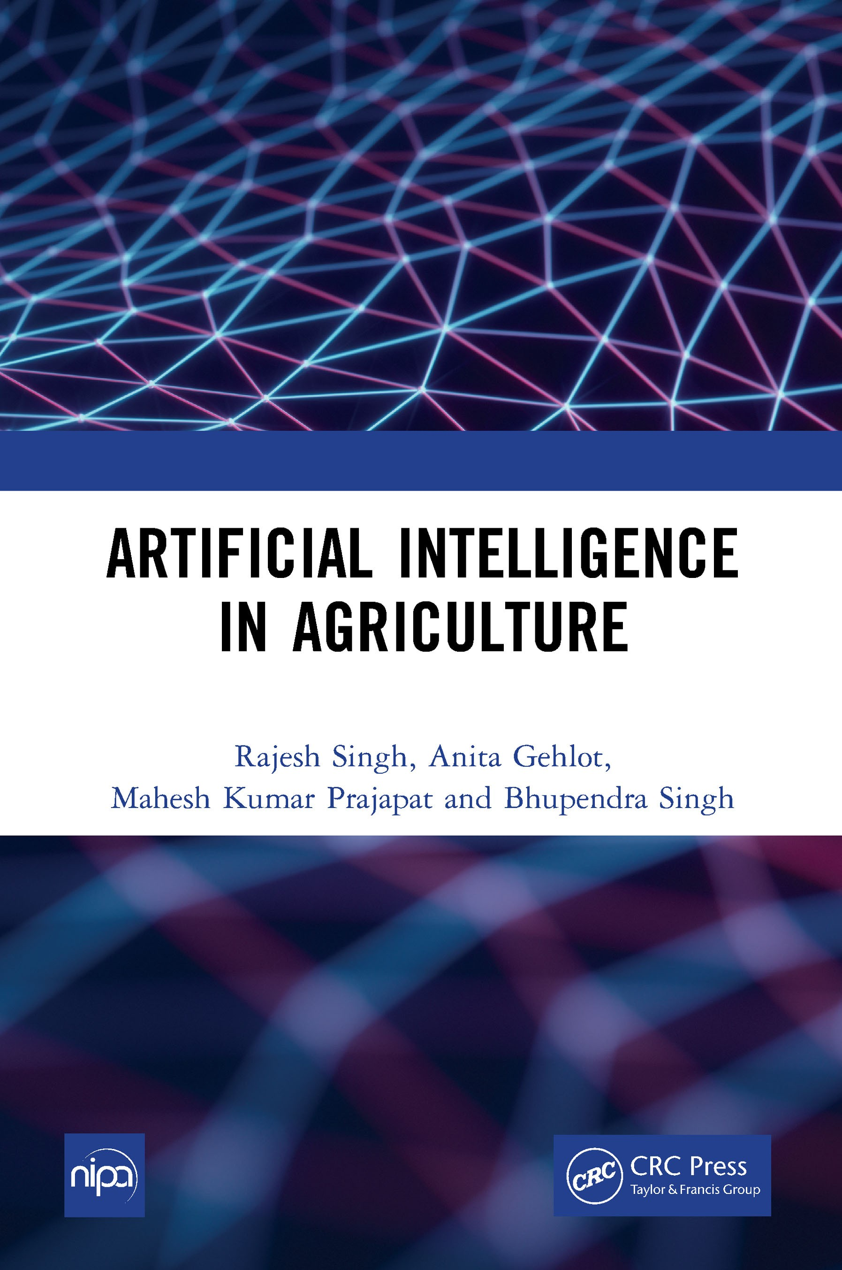

DOI: 10.4324/9781315542652

ARTIFICIAL INTELLIGENCE IN AGRICULTURE

About the Authors
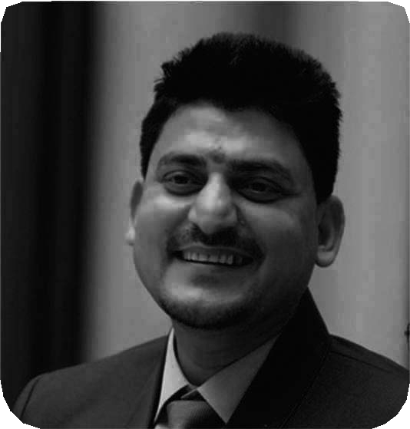Dr. Rajesh Singh is currently associated with Lovely Professional University as Professor with more than Sixteen years of experience in academics. He has been awarded as gold medalist in M.Tech from RGPV, Bhopal (M.P) India and honors in his B.E from Dr.
B.R. Ambedkar University, Agra (U.P), India. His area of expertise includes embedded systems, robotics, wireless sensor networks and Internet of Things. He has been honored as keynote speakers and session
chair to international/national conferences, faculty development programs and workshops. He has hundred and fifty two patents in his account. He has published more than hundred research papers in referred journals/ conferences and twenty four books in the area of Embedded Systems and Internet of Things with reputed publishers like CRC/Taylor & Francis, Narosa, GBS, IRP, NIPA, River Publishers, Bentham Science and RI publication. He is editor to a special issue published by AISC book series, Springer in 2017 & 2018 and IGI global in 2019. Under his mentorship students have participated in national/international competitions including “Innovative Design Challenge competition” by Texas and DST and Laureate award of excellence in robotics engineering, Madrid, Spain in 2014 & 2015. His team has been the winner of “Smart India Hackathon-2019” hardware version conducted by MHRD, Government of India for the problem statement of Mahindra & Mahindra. Under his mentorship students team got “InSc award 2019” under students projects program. He has been awarded with “Gandhian Young Technological Innovation (GYTI) Award”, as Mentor to “On Board Diagnostic Data Analysis System-OBDAS”, Appreciated under “Cutting Edge Innovation” during Festival of Innovation and Entrepreneurship at Rashtrapati Bahawan, India in 2018. He has been honored with “Certificate of Excellence” from 3rd faculty branding awards-15, Organized by EET CRS research wing for excellence in professional education and Industry, for the category “Award for Excellence in Research”, 2015 and young investigator award at the International Conference on Science and Information in 2012.
Dr. Anita Gehlot is currently associated with Lovely Professional University as Associate Professor with more than twelve years of experience in academics. Her area of expertise includes embedded systems, wireless sensor networks and Internet of Things. She has been honoured as keynote speakers and session chair to international/national conferences, faculty development programs and workshops. She has

hundred and thirty two patents in her account. She has published more than seventy research papers in referred journals/conferences and twenty four books in the area of Embedded Systems and Internet of Things with reputed publishers like CRC/Taylor & Francis, Narosa, GBS, IRP, NIPA, River Publishers, Bentham Science and RI publication. She is editor to a special issue published by AISC book series, Springer in 2018 and IGI global in 2019. She has been awarded with “certificate of appreciation” from University of Petroleum and Energy Studies for exemplary work. Under her mentorship students team got “InSc award 2019” under students projects program. She has been awarded with “Gandhian Young Technological Innovation (GYTI) Award”, as Mentor to “On Board Diagnostic Data Analysis System-OBDAS”, Appreciated under “Cutting Edge Innovation” during Festival of Innovation and Entrepreneurship at Rashtrapati Bahawan, India in 2018.

Mahesh Kumar Prajapat is currently pursuing his Master’s Degree in Computer Science and Engineering from Lovely Professional University. His major research area is Artificial Intelligence by which he has 16 patents in His account. He has won AIU Anveshan 2020 a research competition with 3rd position. He is a founder of startup Orphorhard which works for the development of orphans and underprivileged children
around the country. He has done specialization courses which include deep learning, data science from Coursera, and IBM. he is always Acquiring broaden Horizon, Much observant in nature, perceiving self-generated ideologies and implementing that same and Love to explore different fields with full zest.
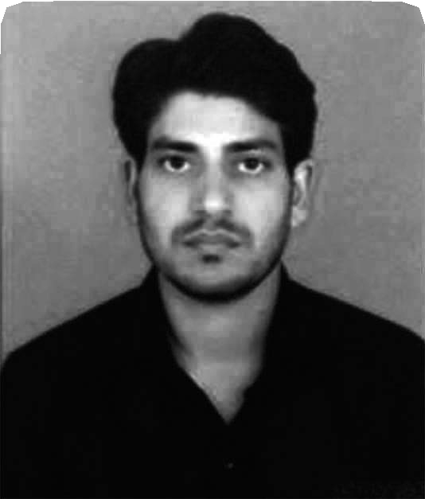
Bhupendra Singh is Managing director of Schematics Microelectronics and provides Product design and R&D support to industries and Universities. He has completed BCA, PGDCA, M.Sc. (CS), M.Tech and has more than eleven years of experience in the field of Computer Networking and Embedded systems. He has has published twelve books in the area of Embedded Systems and Internet of Things with reputed publishers like CRC/Taylor & Francis, Narosa, GBS, IRP, NIPA, River Publisher, Cambridge Scholar, Bentham Science and RI Publication.



ARTIFICIAL INTELLIGENCE
IN AGRICULTURE

Rajesh Singh
Lovely Professional University Jalandhar, Punjab, India

Anita Gehlot
Lovely Professional University Jalandhar, Punjab, India

Mahesh Kumar Prajapat
Lovely Professional University Jalandhar, Punjab, India

Bhupendra Singh
Schematics Microelectronics, India




NEW INDIA PUBLISHING AGENCY
New Delhi-110 034

First published 2022 by CRC Press
2 Park Square, Milton Park, Abingdon, Oxon, OX14 4RN
and by CRC Press
6000 Broken Sound Parkway NW, Suite 300, Boca Raton, FL 33487-2742
© 2022 New India Publishing Agency
CRC Press is an imprint of Informa UK Limited
The right of Rajesh Singh et al. to be identified as authors of this work has been asserted in accordance with sections 77 and 78 of the Copyright, Designs and Patents Act 1988.
All rights reserved. No part of this book may be reprinted or reproduced or utilised in any form or by any electronic, mechanical, or other means, now known or hereafter invented, including photocopying and recording, or in any information storage or retrieval system, without permission in writing from the publishers.
For permission to photocopy or use material electronically from this work, access www. copyright.com or contact the Copyright Clearance Center, Inc. (CCC), 222 Rosewood Drive, Danvers, MA 01923, 978-750-8400. For works that are not available on CCC please contact mpkbookspermissions@tandf.co.uk
Trademark notice: Product or corporate names may be trademarks or registered trademarks, and are used only for identification and explanation without intent to infringe.
Print edition not for sale in South Asia (India, Sri Lanka, Nepal, Bangladesh, Pakistan or Bhutan).
British Library Cataloguing-in-Publication Data
A catalogue record for this book is available from the British Library
Library of Congress Cataloging-in-Publication Data
A catalog record has been requested
ISBN: 978-1-032-15810-5 (hbk)
ISBN: 978-1-003-24575-9 (ebk) DOI: 10.1201/9781003245759


Preface

This book is a platform for anyone who wishes to explore Artificial Intelligence in the field of agriculture from scratch or broaden their understanding and its uses.
This book offers a practical, hands-on exploration of Artificial Intelligence, machine learning, deep Learning, computer vision and Expert system with proper examples to understand. This book also covers the basics of python with example so that anyone can easily understand and utilize artificial Intelligence in agriculture field.
This book is divided into two parts wherein first part talks about the artificial intelligence and its impact in the agriculture with all its branches and their basics. The second part of the book is purely implementation of algorithms and use of different libraries of machine learning, deep learning and computer vision to build useful and sightful projects in real time which can be very useful for you to have better understanding of artificial Intelligence.
After reading this book, you’ll have an understanding of what Artificial Intelligence is, where it is applicable, and what are its different branches, which can be useful in different scenarios. You’ll be familiar with the standard workflow for approaching and solving machine-learning problems, and you’ll know how to address commonly encountered issues. You’ll be able to use Artificial Intelligence to tackle real-world problems ranging from crop health prediction to field surveillance analytics, classification to recognition of species of plants etc.,
Authors are thankful to the publisher for the support and encouragement to write this book.
Authors



Contents
Preface vii
PART A: Fundamental of Artificial Intelligence
Chapter 1 Artificial Intelligence 3
Chapter 2 Learning Python for Artificial Intelligence 8
Chapter 3 Machine Learning 41
Chapter 4 Deep Learning 50
Chapter 5 Computer Vision 64
Chapter 6 Knowledge Based Expert System 73
PART B: Implementation of Artificial Intelligence

Chapter 7 | Tools for Artificial Intelligence | 83
Chapter 8 | Important Libraries for AI | 97
Chapter 9 | Machine Learning Algorithms | 106
Chapter 10 | Disease Classification and Detection in Plants | 137
Chapter 11 | Species Recognition in Flowers | 151
Chapter 12 | Precision Farming | 168



PART A: FUNDAMENTAL OF ARTIFICIAL INTELLIGENCE



